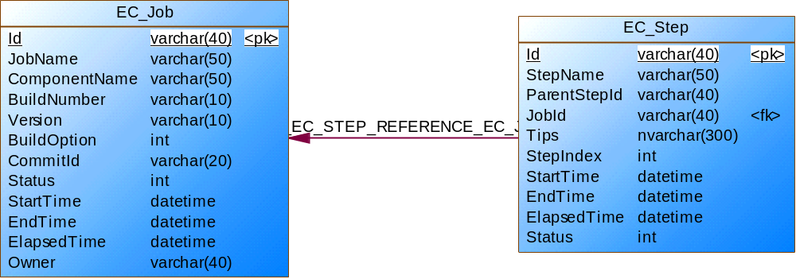
Table - EC_Job
Name | Code | Data Type | Length | Primary | Foreign Key
JobId | ID | varchar(40) | 40 | TRUE | FALSE
JobName | JOBNAME | varchar(50) | 50 | FALSE | FALSE
ComponentName | COMPONENTNAME | varchar(50) | 50 | FALSE | FALSE
BuildNumber | BUILDNUMBER | varchar(10) | 10 | FALSE | FALSE
Version | VERSION | varchar(10) | 10 | FALSE | FALSE
BuildOption | BUILDOPTION | int |  | FALSE | FALSE
CommitId | COMMITID | varchar(20) | 20 | FALSE | FALSE
Status | STATUS | int |  | FALSE | FALSE
StartTime | STARTTIME | datetime |  | FALSE | FALSE
EndTime | ENDTIME | datetime |  | FALSE | FALSE
waitTime | ELAPSEDTIME | datetime |  | FALSE | FALSE
 | OWNER | varchar(40) | 40 | FALSE | FALSE

Table - EC_Step
Name | Code | Data Type | Length | Primary | Foreign Key
stepId | ID | varchar(40) | 40 | TRUE | FALSE
StepName | STEPNAME | varchar(50) | 50 | FALSE | FALSE
 | PARENTSTEPID | varchar(40) | 40 | FALSE | FALSE
JobId | JOBID | varchar(40) | 40 | FALSE | TRUE
Tips | TIPS | nvarchar(300) | 300 | FALSE | FALSE
StepIndex | STEPINDEX | int |  | FALSE | FALSE
StartTime | STARTTIME | datetime |  | FALSE | FALSE
EndTime | ENDTIME | datetime |  | FALSE | FALSE
waitTime | ELAPSEDTIME | datetime |  | FALSE | FALSE
Status | STATUS | int |  | FALSE | FALSE
resoucename
authorName

 |  | Stash Git-Commit
id | commitId |  | Timestamp | Project | Repository | Branch | Type | Author | Email | Commits

